

**Wednesday, April 20, 2016**

**6:30 p.m. - 8:30 p.m.**

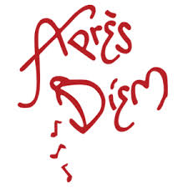

931 Monroe Drive N.E.,

Atlanta, GA 30308

**Guests of the MNA receive complimentary Appetizers & Drink Specials**

**The weather is just right for YOU to join us for a Mingle in Midtown! Meet up with Friends and make new ones at Midtown’s original Mingle in Midtown.**

|  |  |  |
| --- | --- | --- |
|  | www.MidtownAtlanta.org |  |